Lab assignment – 02
Task 1: Statistical Summary for Survey Data
. Scenario:
You are a data analyst intern working with survey responses stored as numerical lists.
❖ Task:
Use Google Gemini in Colab to generate a Python function that reads a list of numbers and calculates the mean, minimum, and maximum values.
❖ Expected Output:
➢ Correct Python function
➢ Output shown in Colab
➢ Screenshot of Gemini prompt and result
Prompt:- Generate a Python function that takes a list of numbers and calculates the mean, minimum, and maximum. Also show a sample input and output suitable for running in Google Colab.
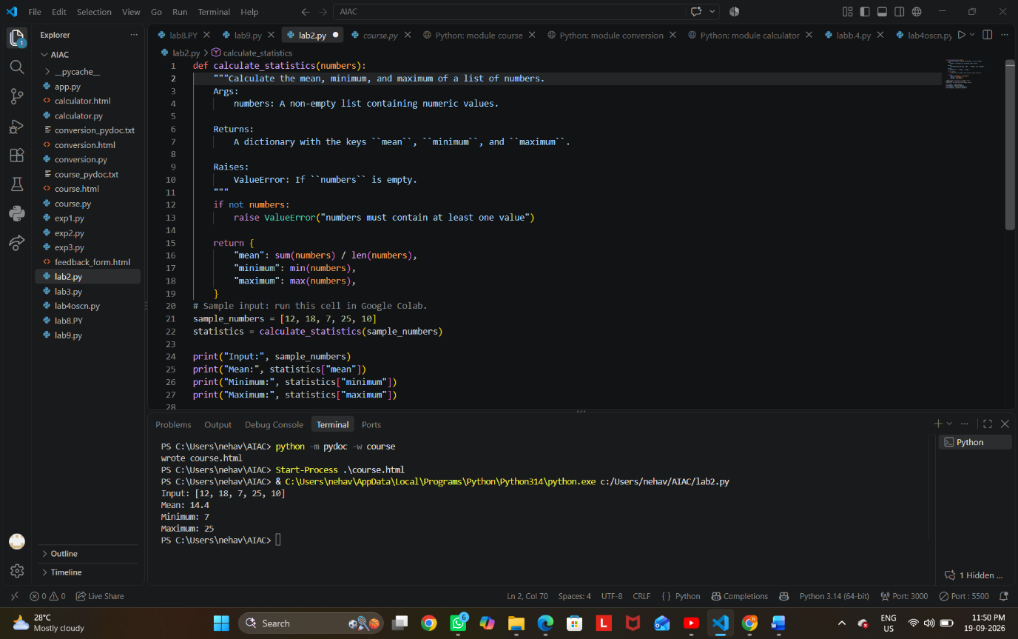

Task 2: Armstrong Number – AI Comparison

- Scenario:
You are evaluating AI tools for numeric validation logic.

- Task:
Generate an Armstrong number checker using Gemini and GitHub Copilot.
Compare their outputs, logic style, and clarity.

- Expected Output:
  - Side-by-side comparison table
  - Screenshots of prompts and generated code

PROMPT:- Generate a Python function to check whether a given number is an Armstrong number. Keep the code simple and explain the logic briefly.
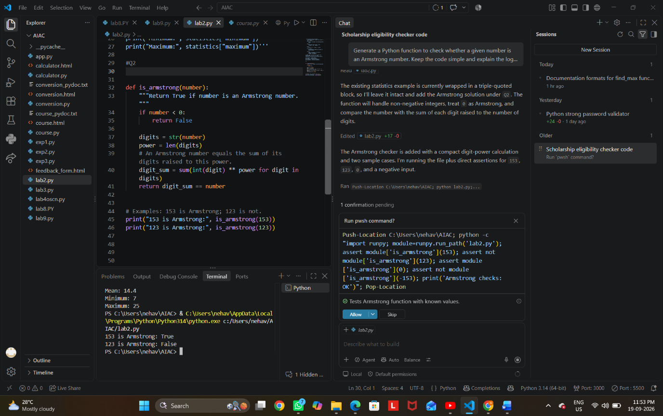

Task 3: Leap Year Validation Using Cursor AI

- Scenario:
You are validating a calendar module for a backend system.

- Task:
Use Cursor AI to generate a Python program that checks whether a given year is a leap year.
Use at least two different prompts and observe changes in code.

- Expected Output:
  - Two versions of code
  - Sample inputs/outputs
Brief comparison
PROMPT:- Create a Python leap year checker with proper input validation and clear comments. Show sample input and output.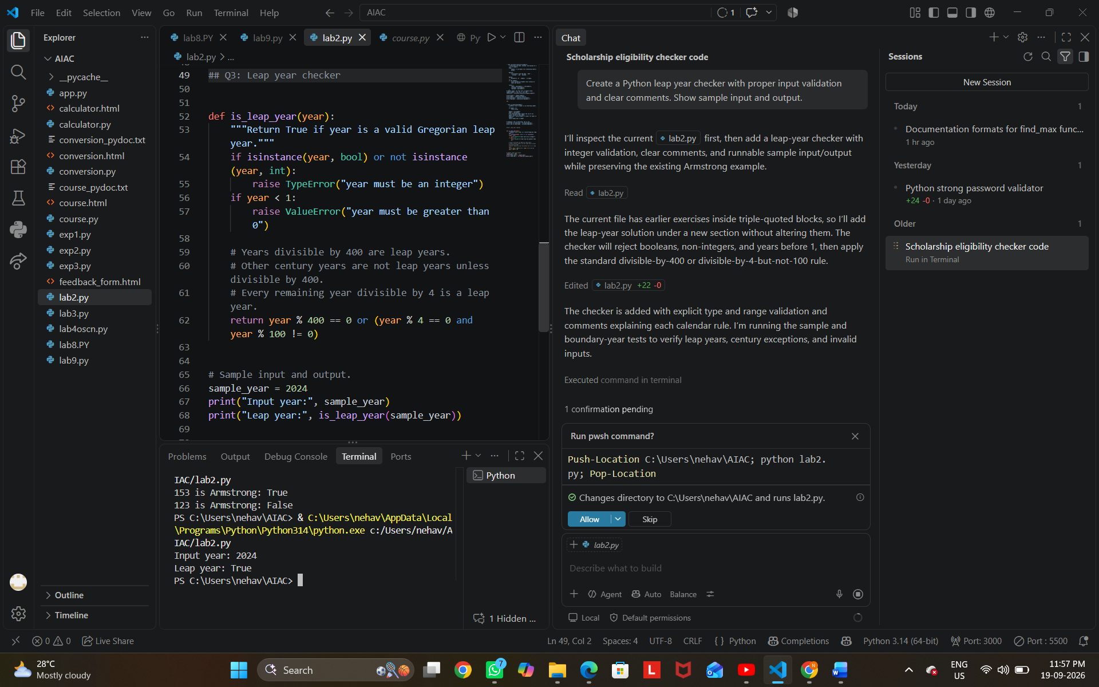

Task 4: Student Logic + AI Refactoring (Odd/Even Sum)

- Scenario:
Company policy requires developers to write logic before using AI.

- Task:
Write a Python program that calculates the sum of odd and even numbers in a tuple, then refactor it using any AI tool.

- Expected Output:
  - Original code
  - Refactored code
  - Explanation of improvements
PROMPT:- Refactor this Python program that calculates the sum of odd and even numbers in a tuple. Keep the logic simple, improve readability and efficiency, and explain the changes made.
